CASE STUDY

Create an Azure Virtual Machine (VM). You need to perform all the tasks within the VM.

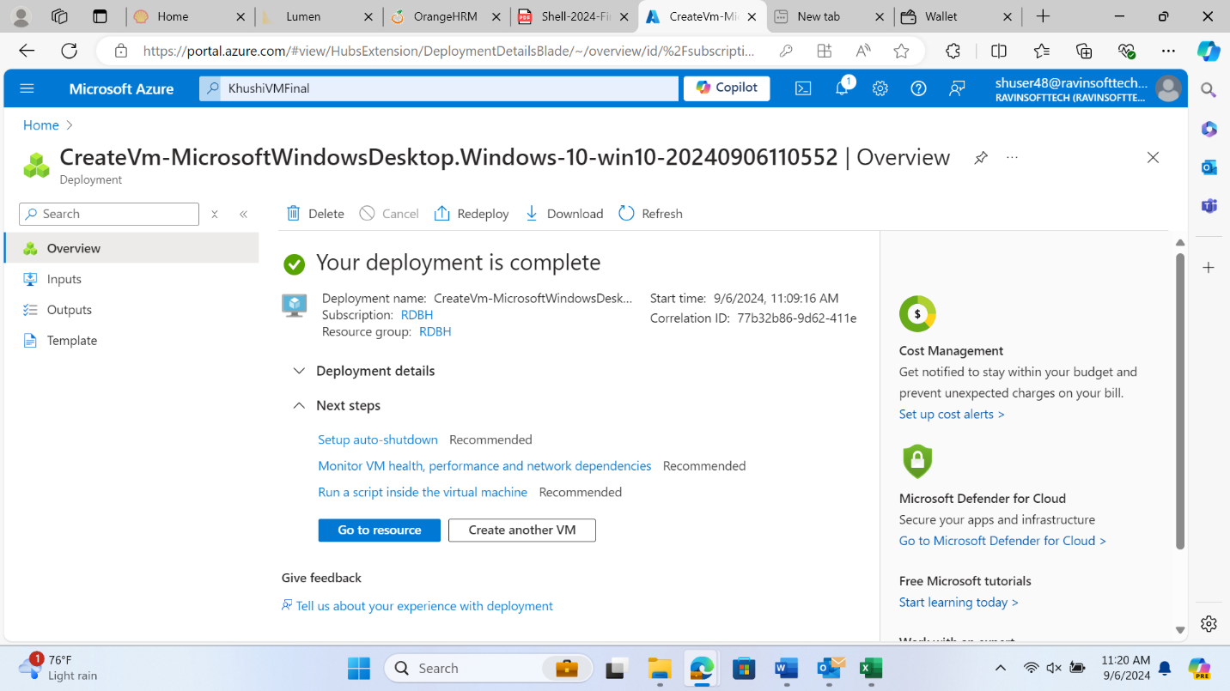

Downloaded the VM

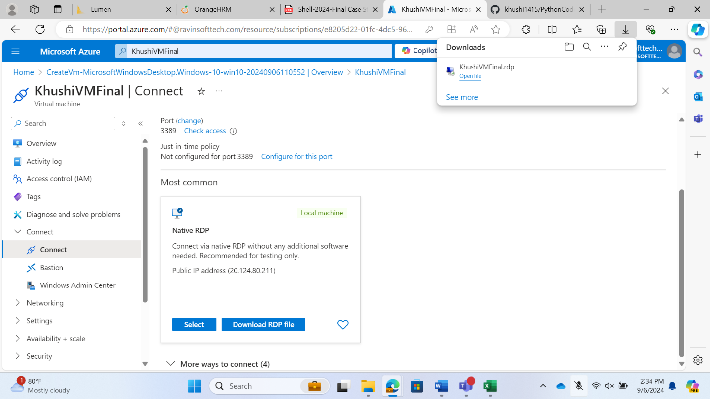

USER STORY-1

Test Cases for user story-1

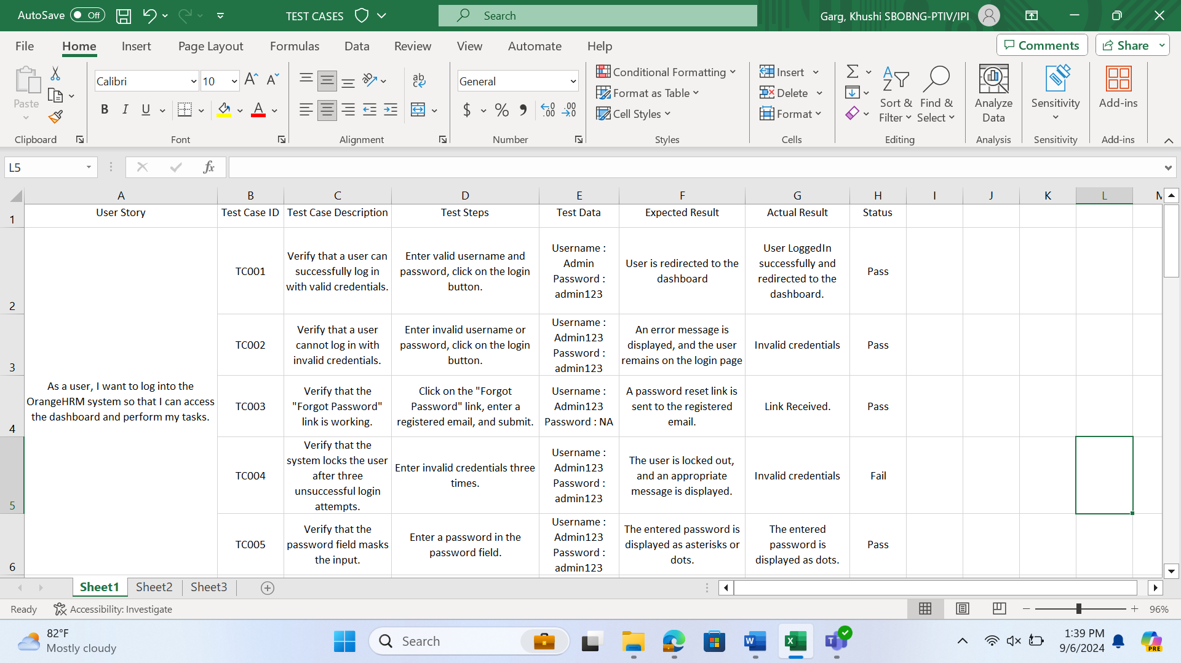

Tasks for user story 1

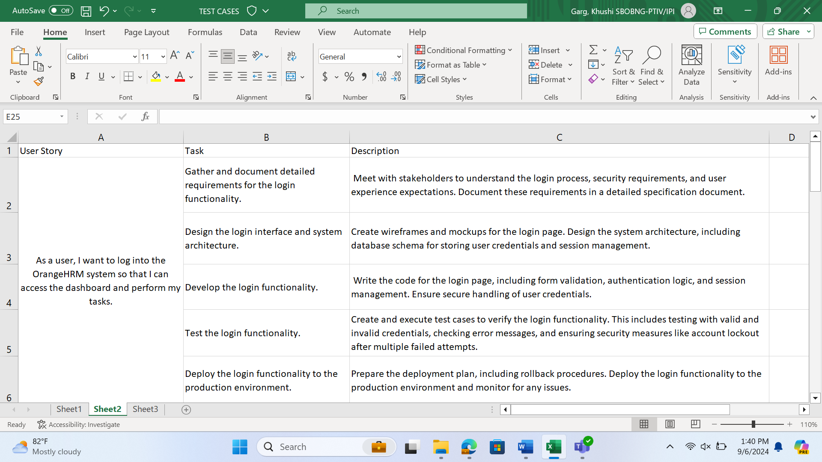

DevOps User Story-1

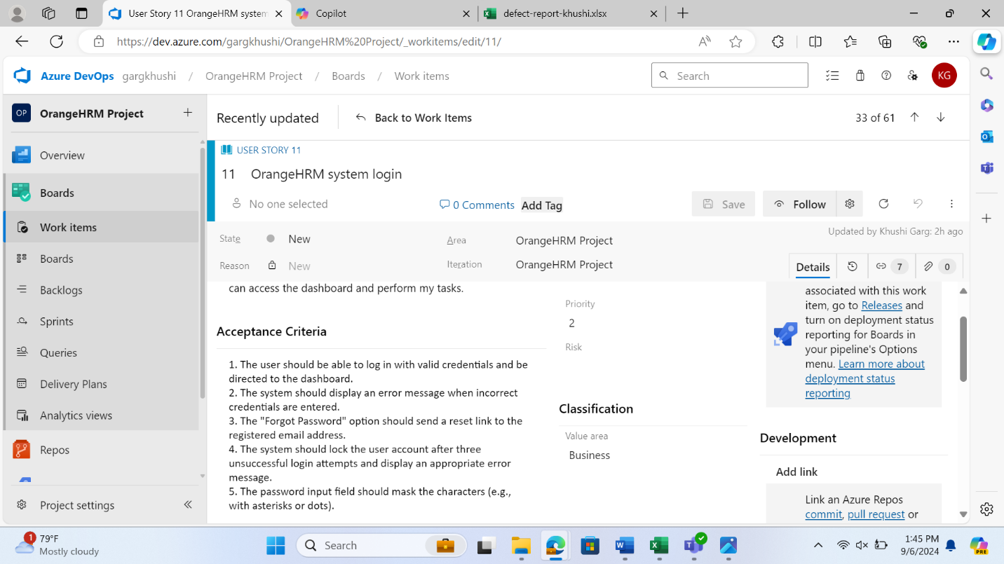

USER STORY -2

Test Cases for user story-2

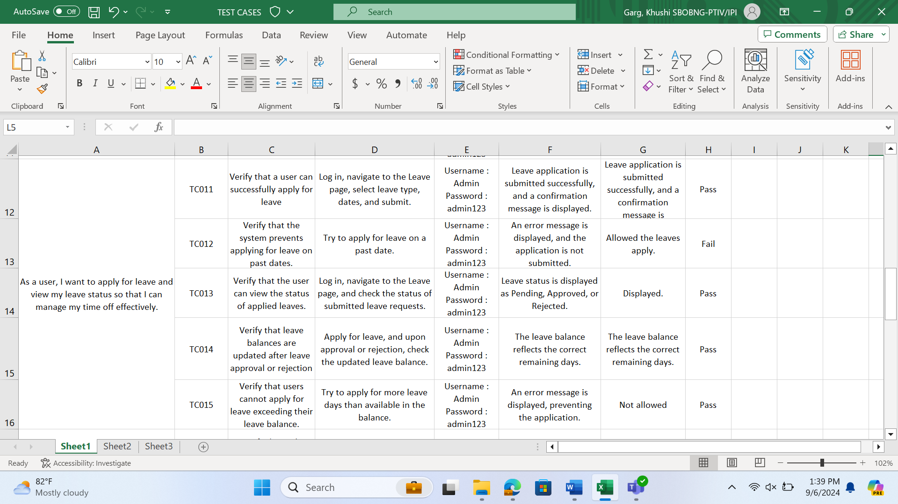

Tasks for the user story -2

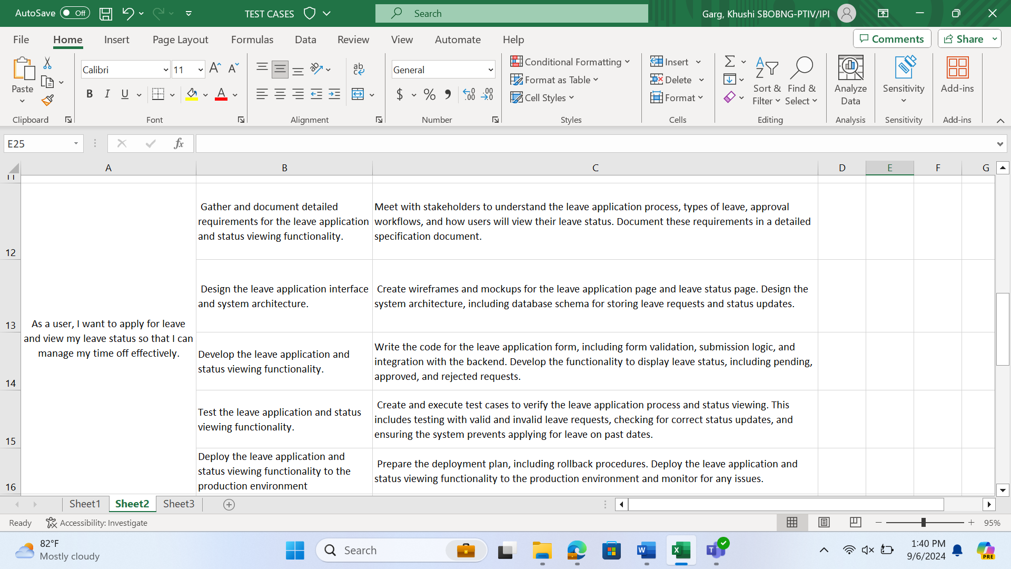

DevOps User Story-2

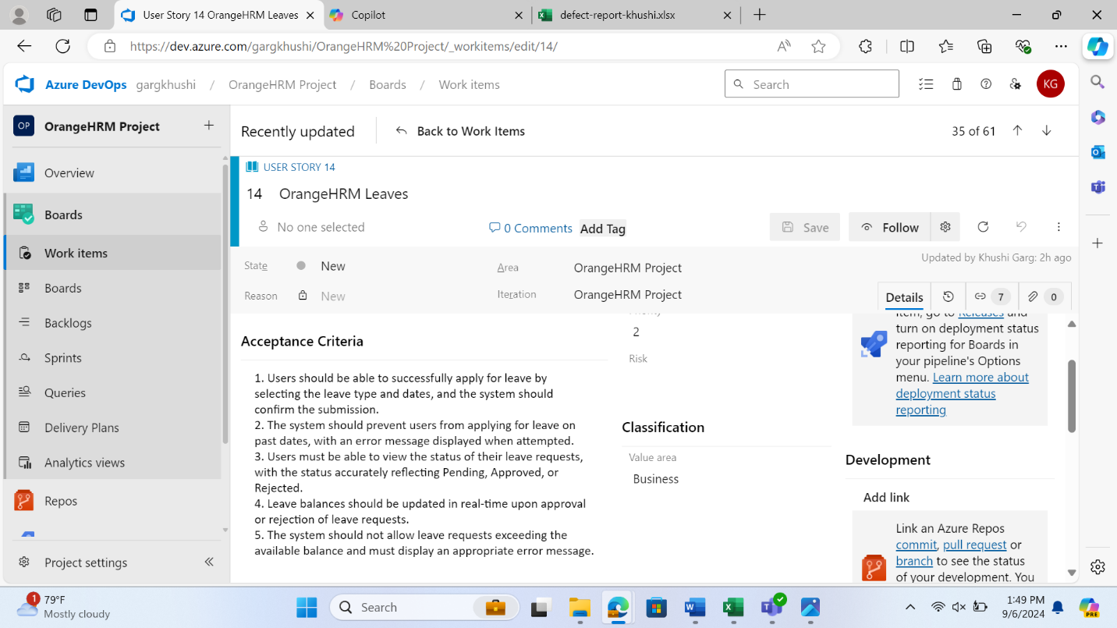

USER STORY-3

Tasks for the user story -3

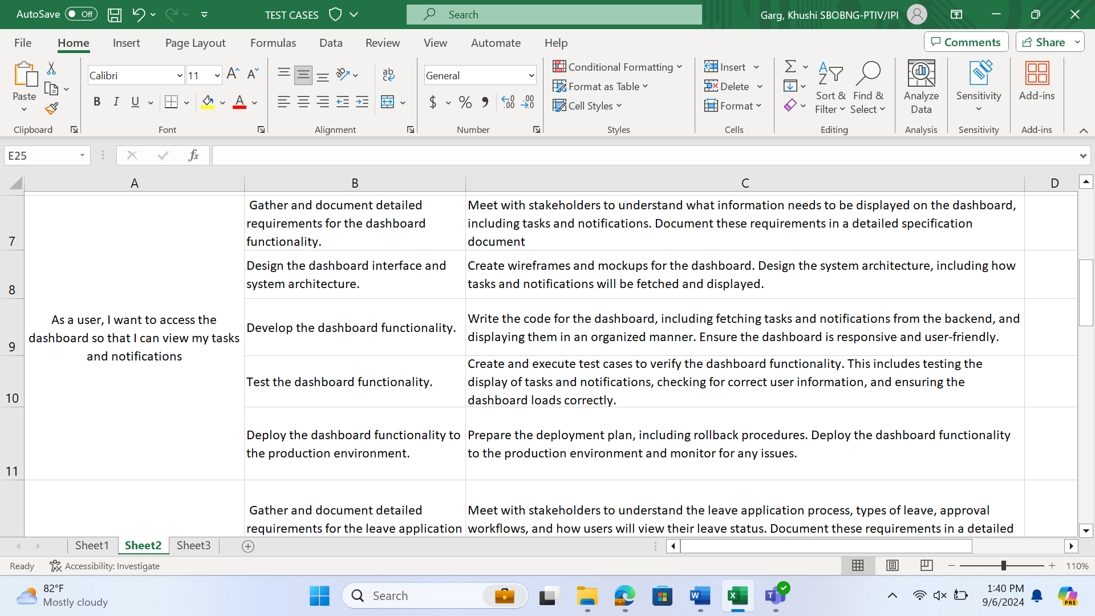

Test Cases for user story 3

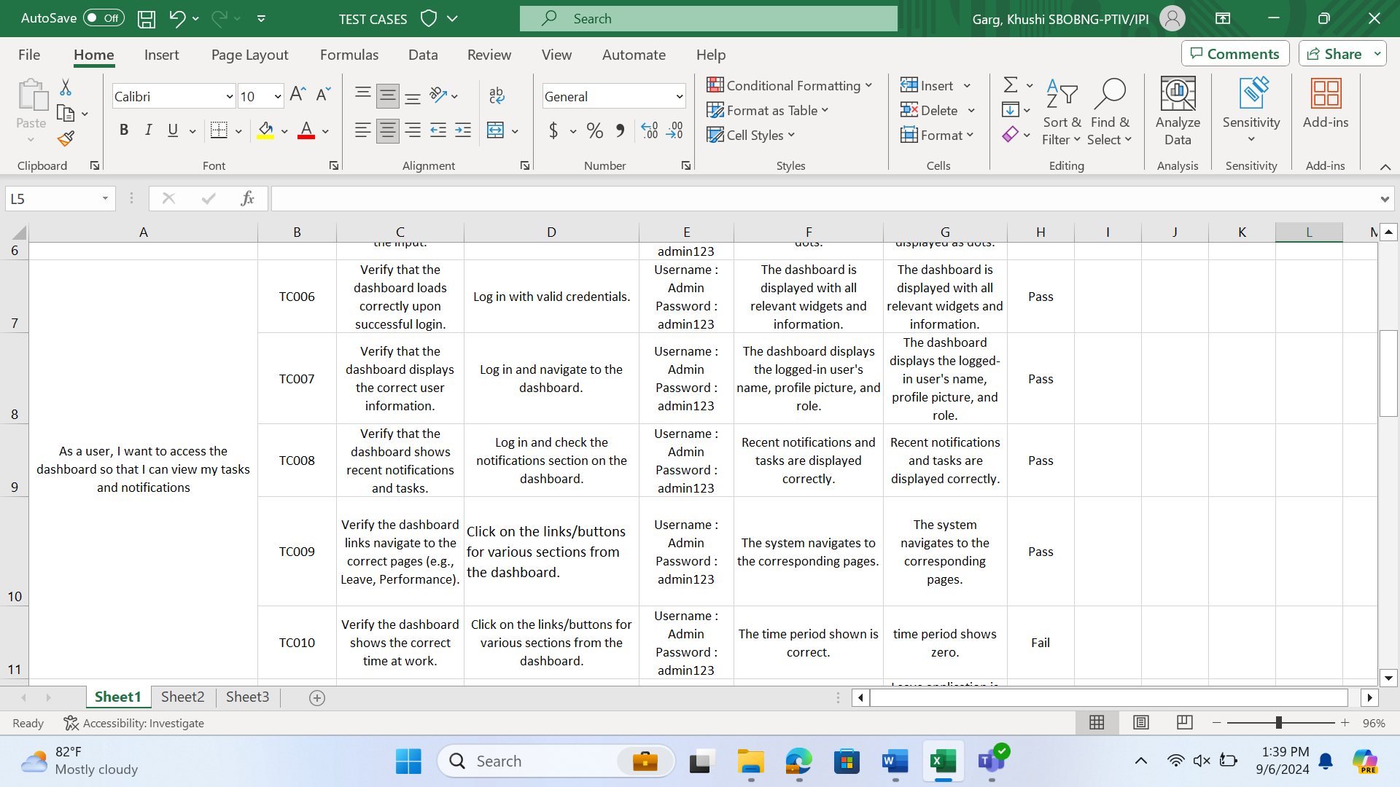

DevOps user story 3

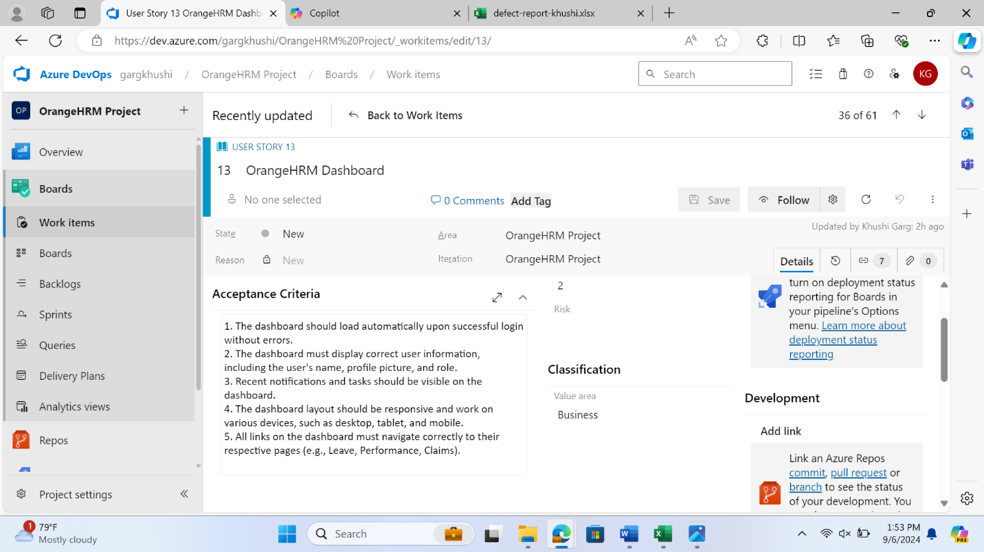

USER STORY-4

Tasks for the user story -4

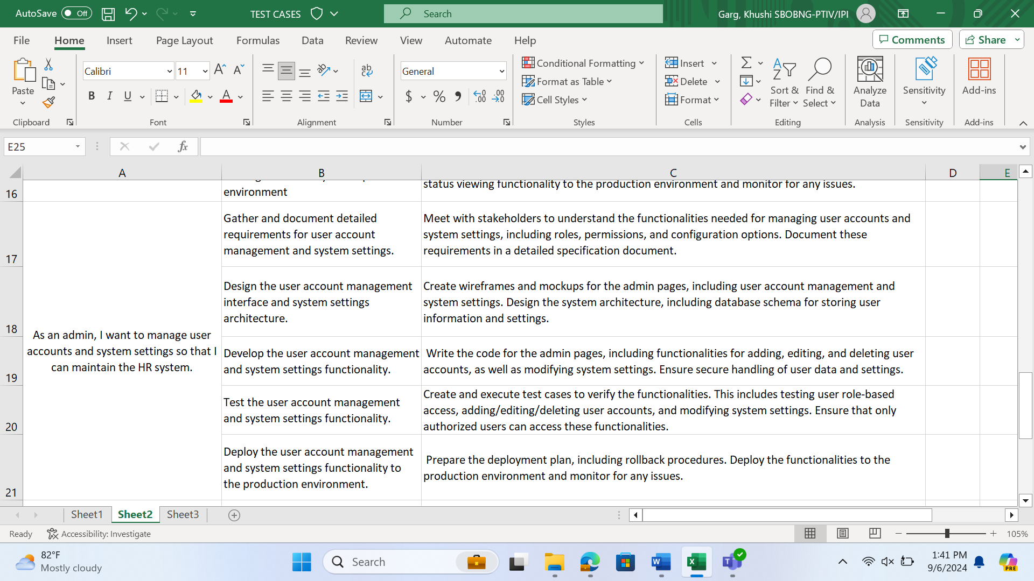

Test Cases for the user story – 4

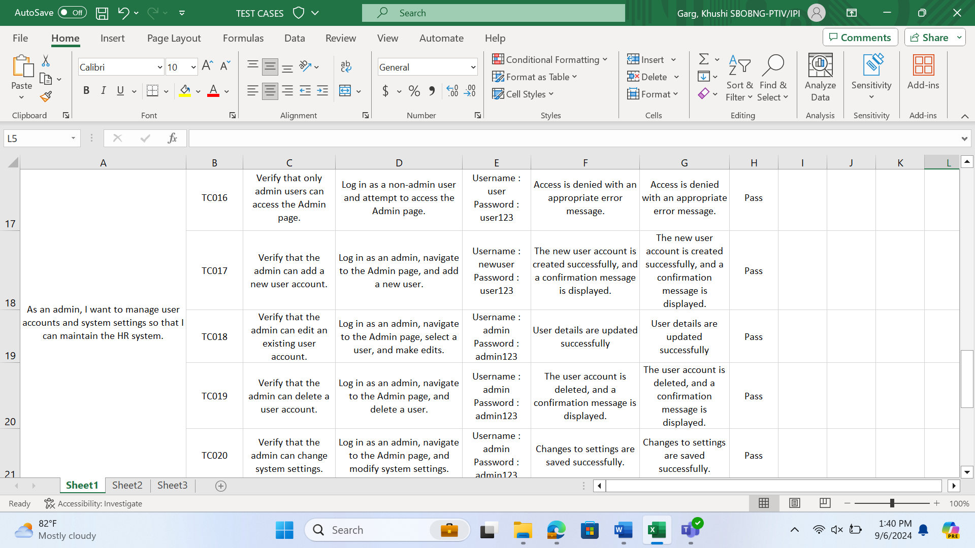

DevOps User Story -4

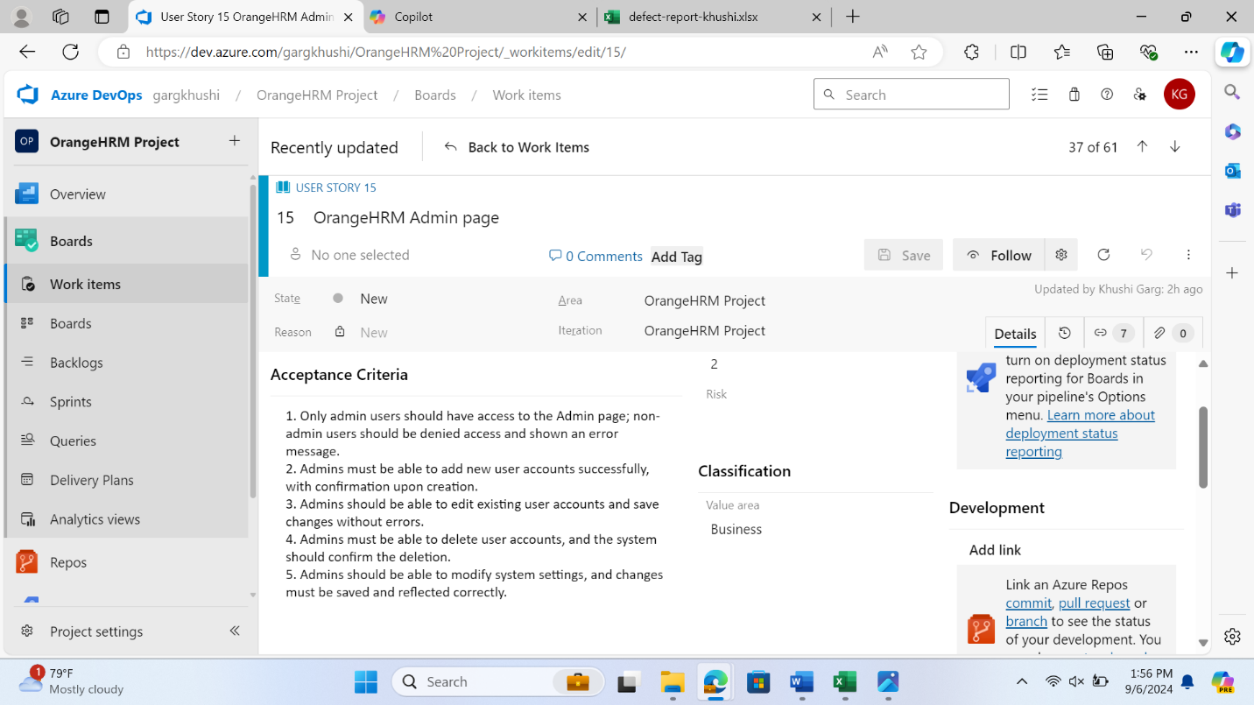

USER STORY -5

Test Cases for the user story-5

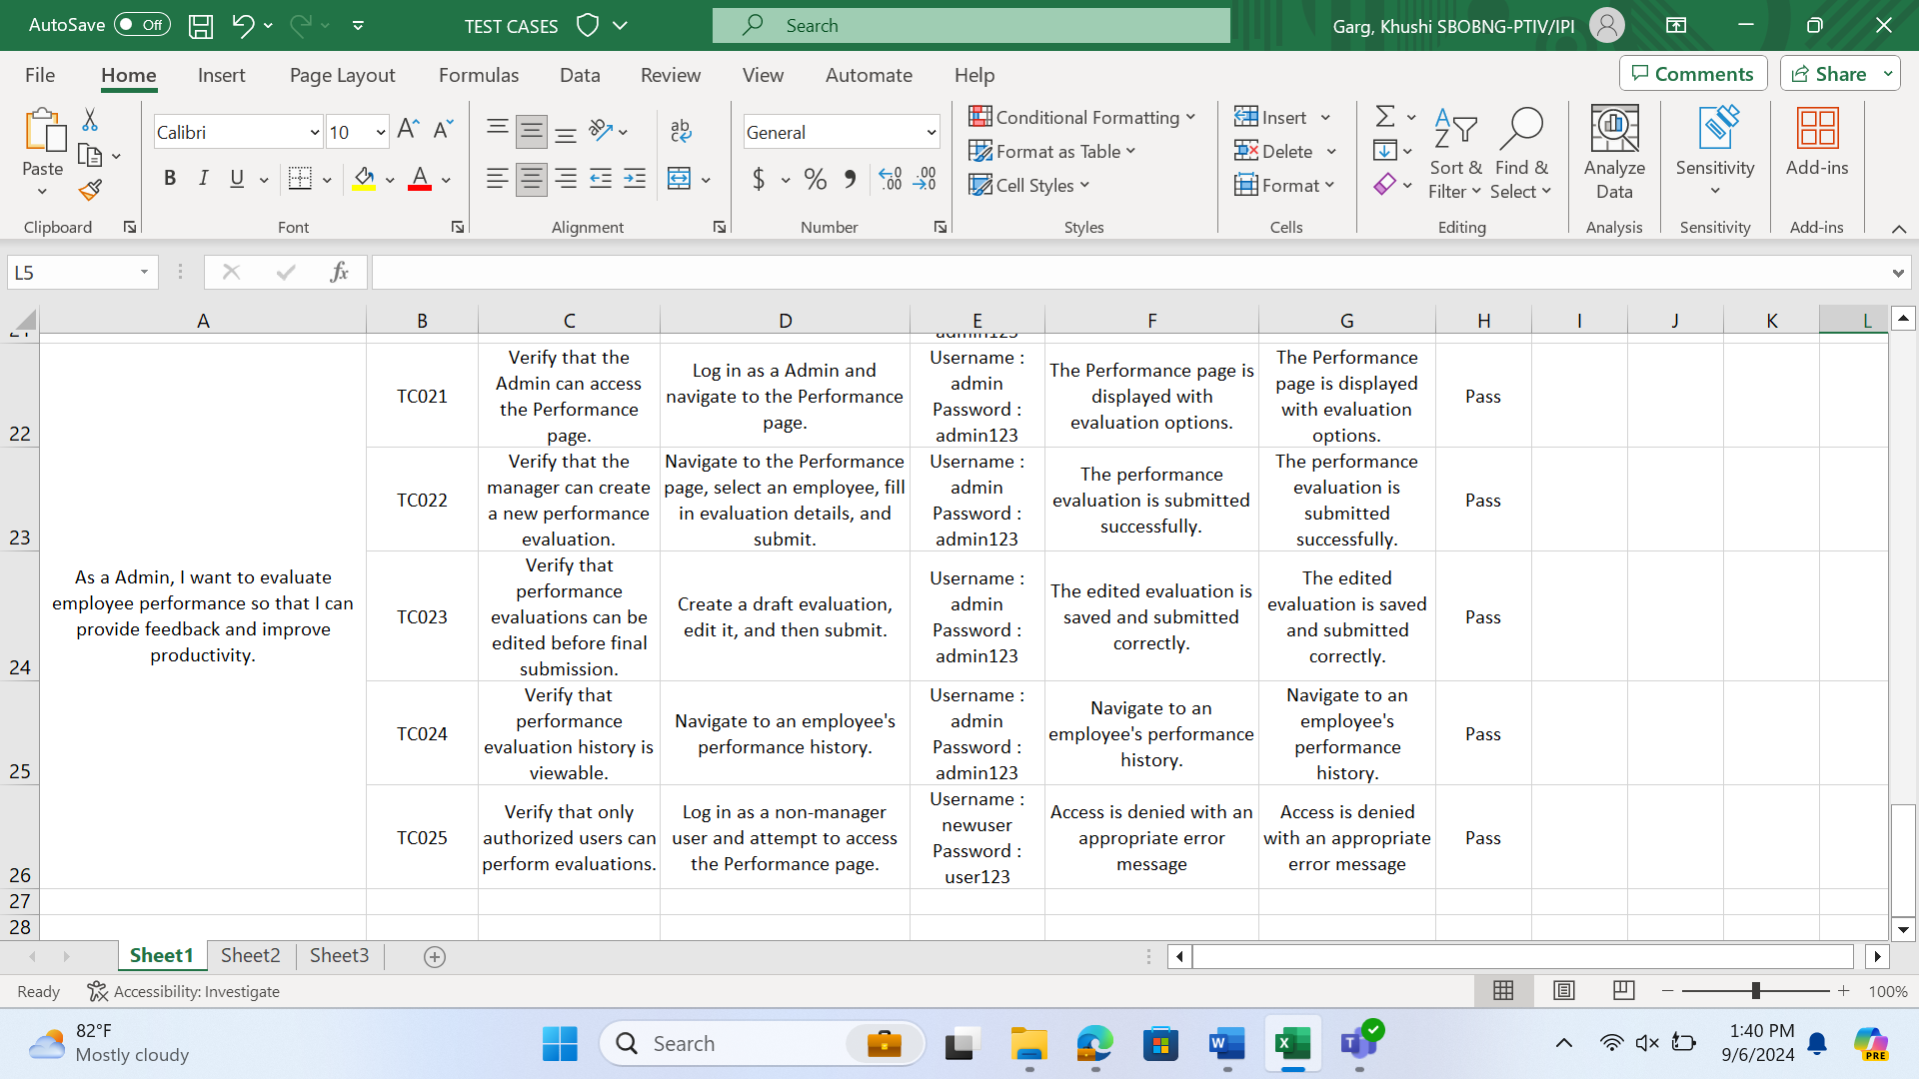

Tasks for the user story - 5

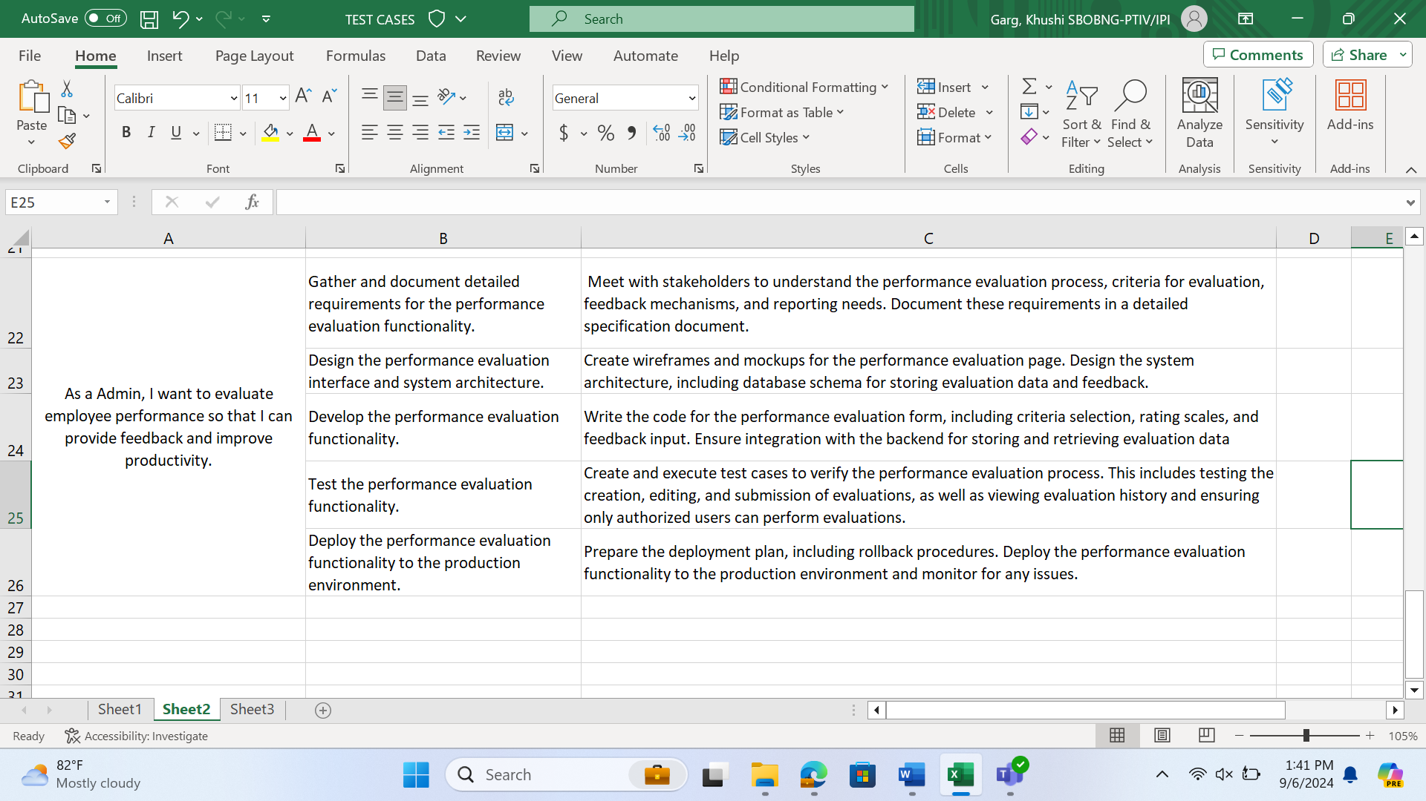

DevOps user story -5

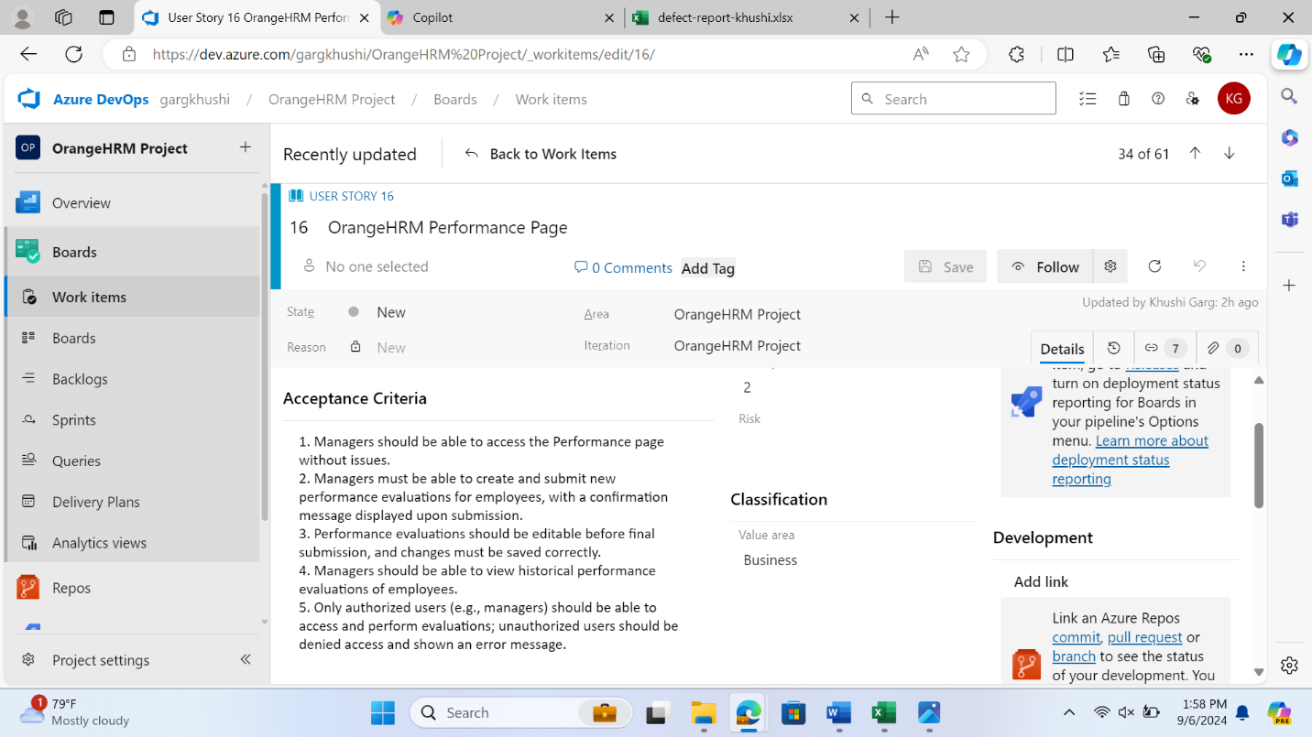

DEFECTS REPORT / BUG REPORT

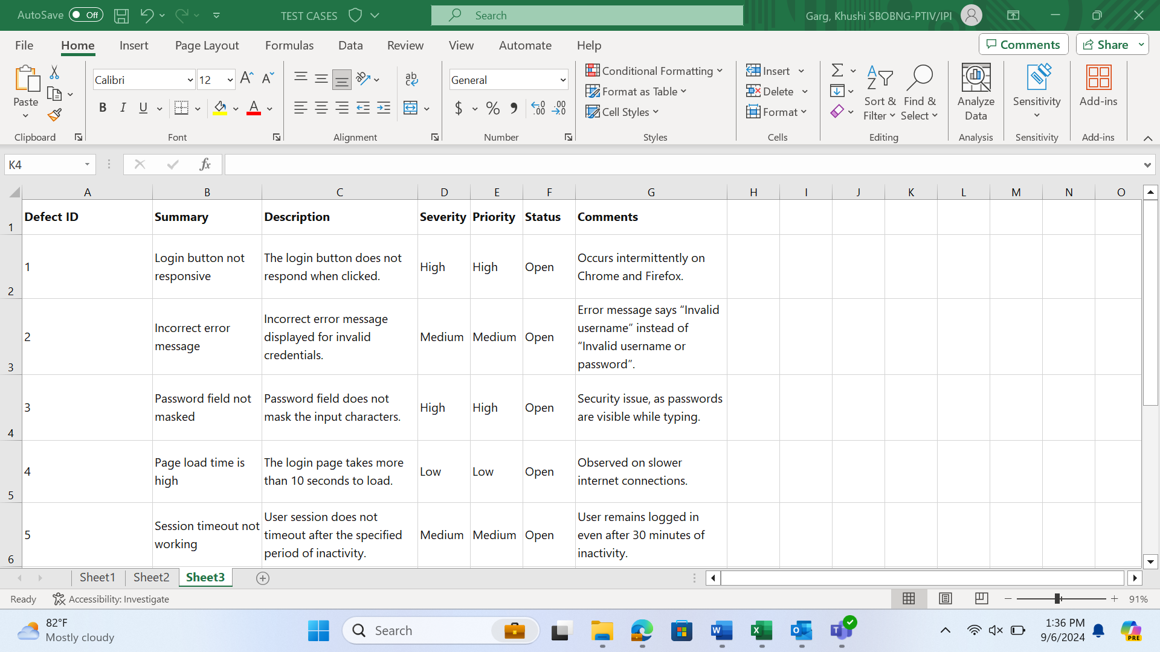

Manual Testing 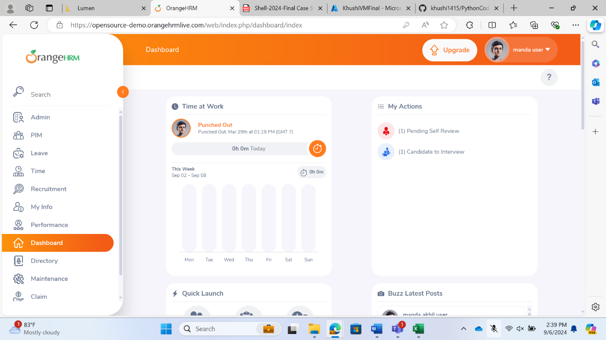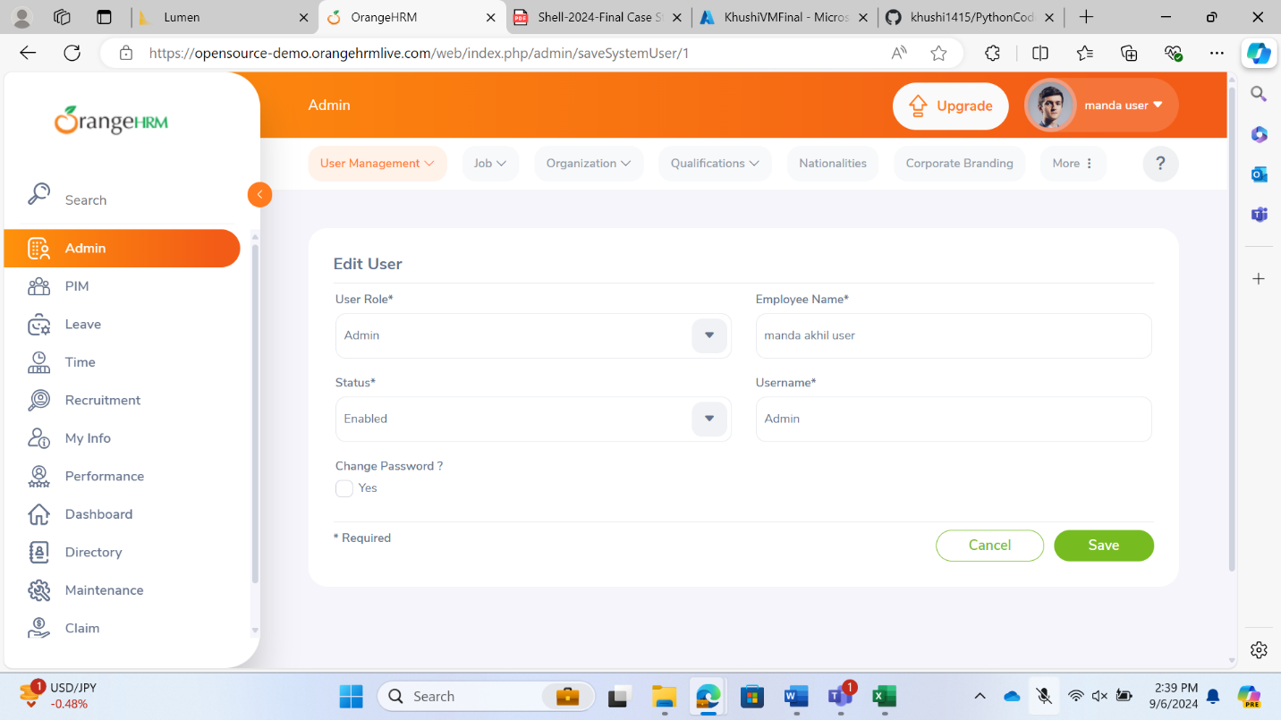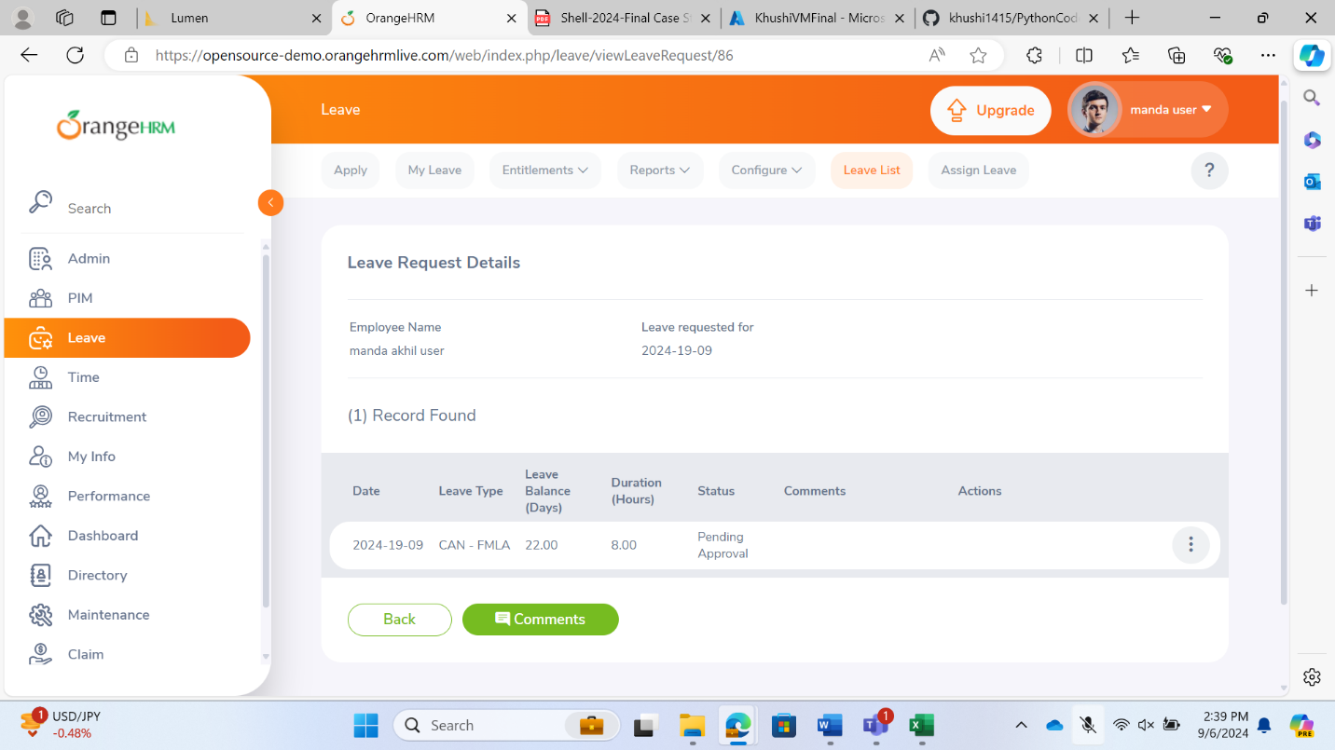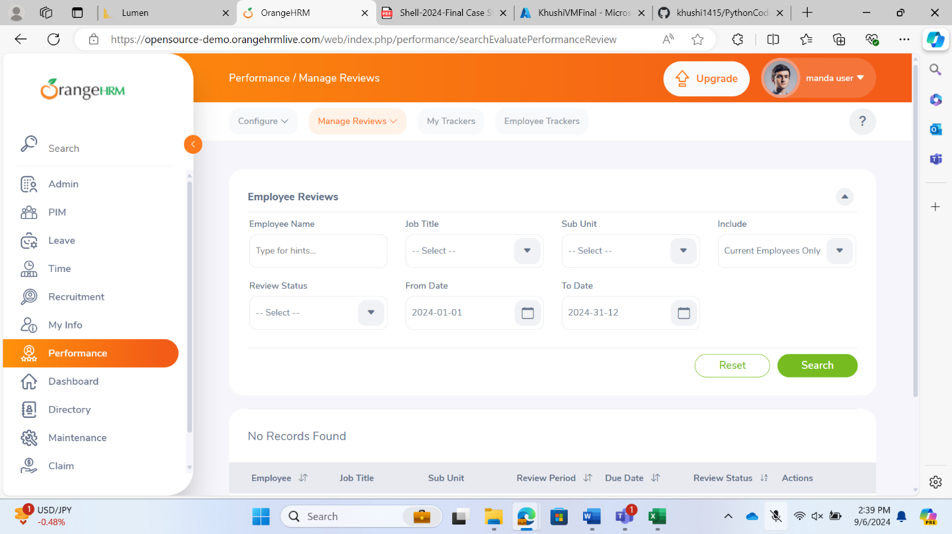

Implementing the CI/CD Pipeline using GitHub Actions

Repo Link: [khushi1415/PythonCode (github.com)](https://github.com/khushi1415/PythonCode)

11. Create a new repository on your GitHub account.

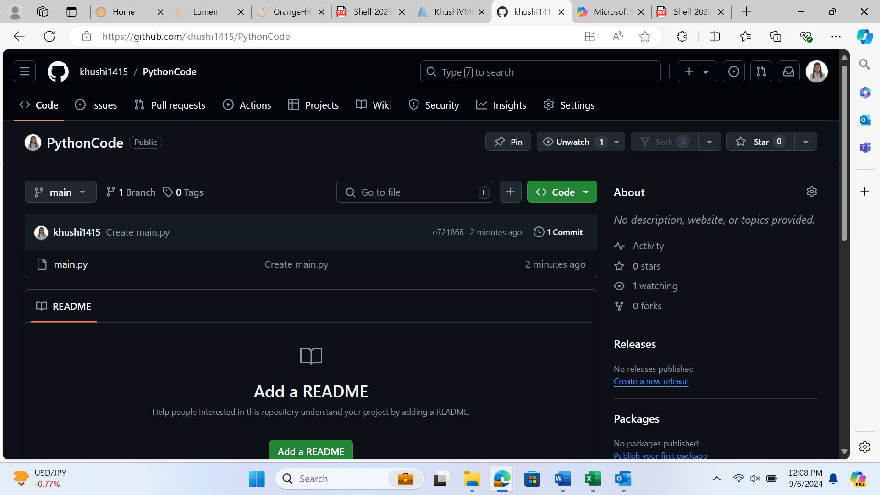

12. Clone the code base of the Java (any preferred language) project into your repository. The project’s codebase would be present in the VM.

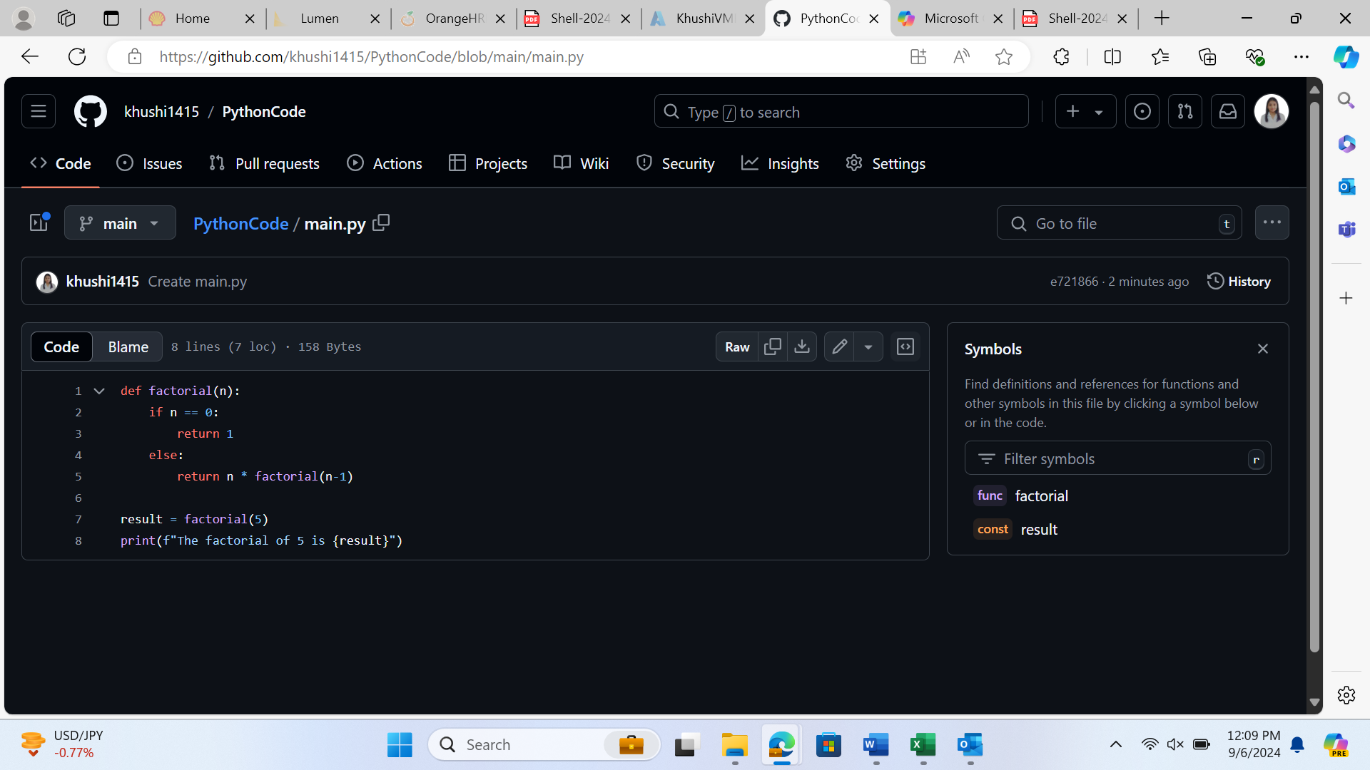

13. Create a New Workflow on GitHub Actions for the Java/Maven code.

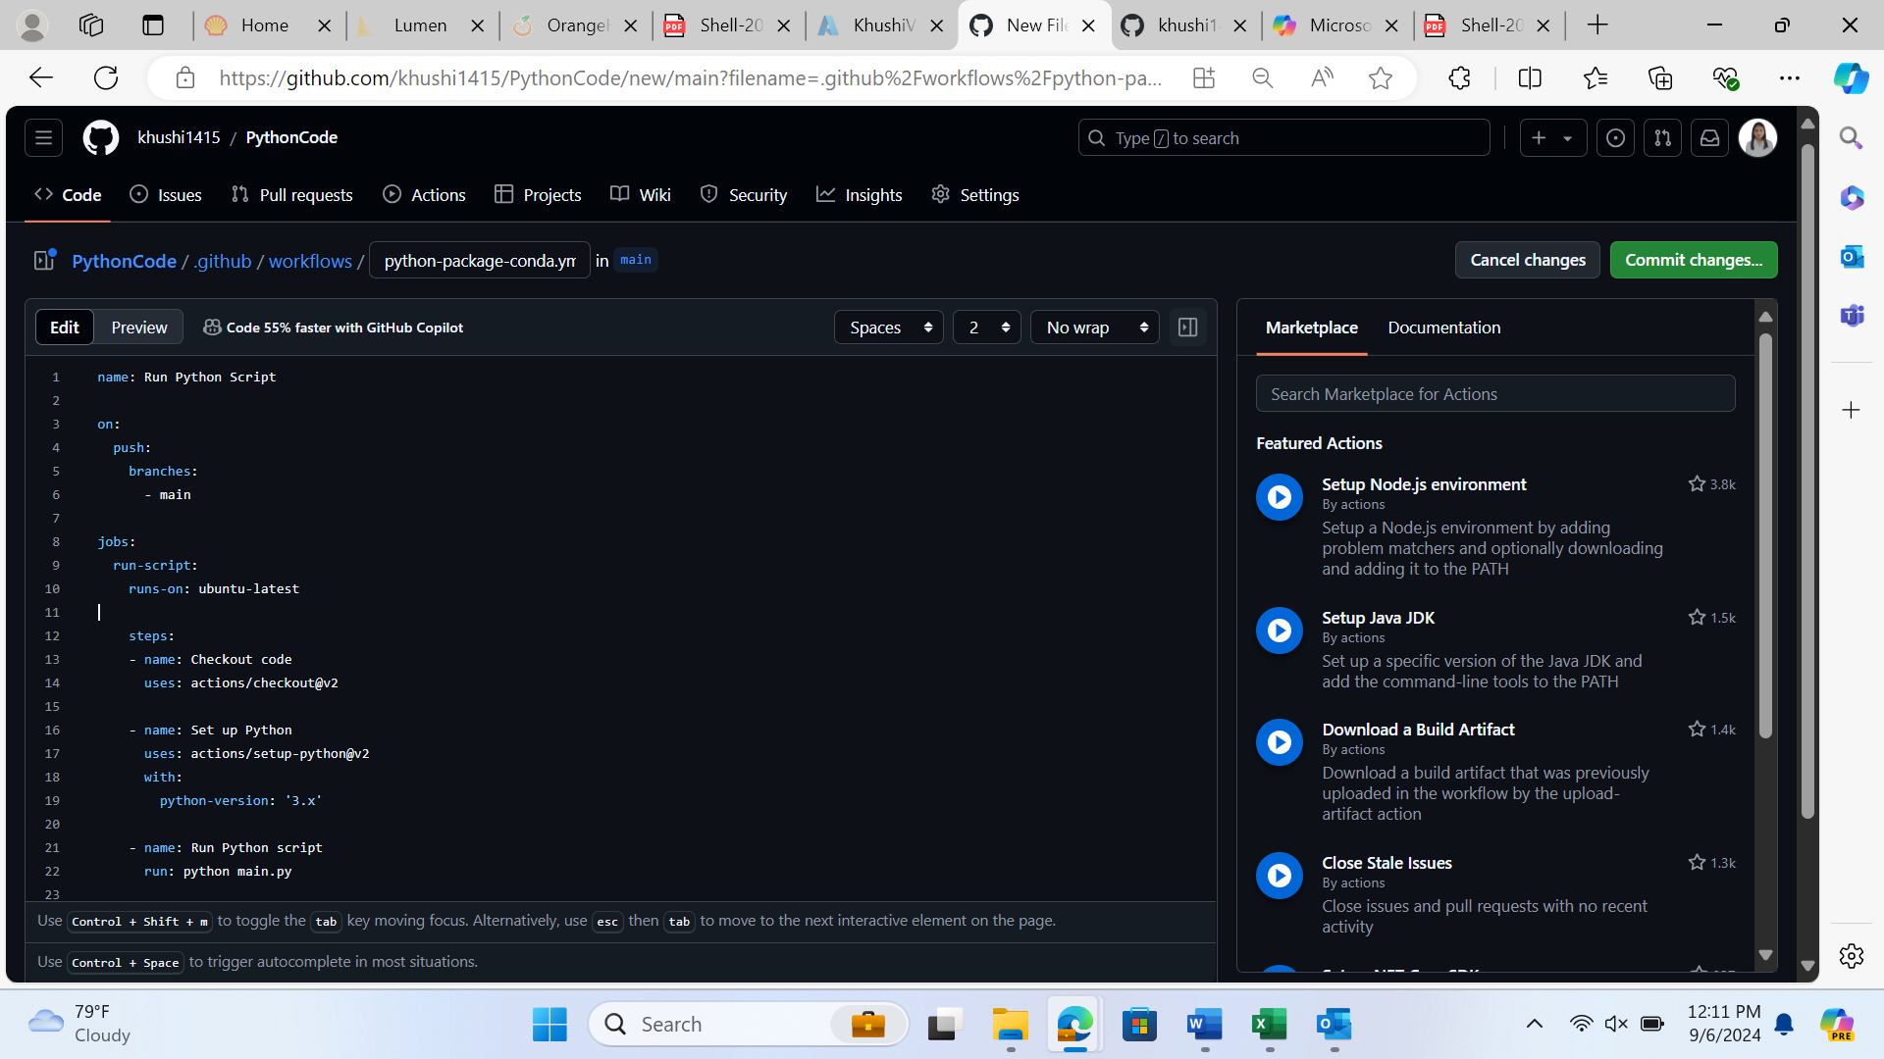

14. Monitor the created build.

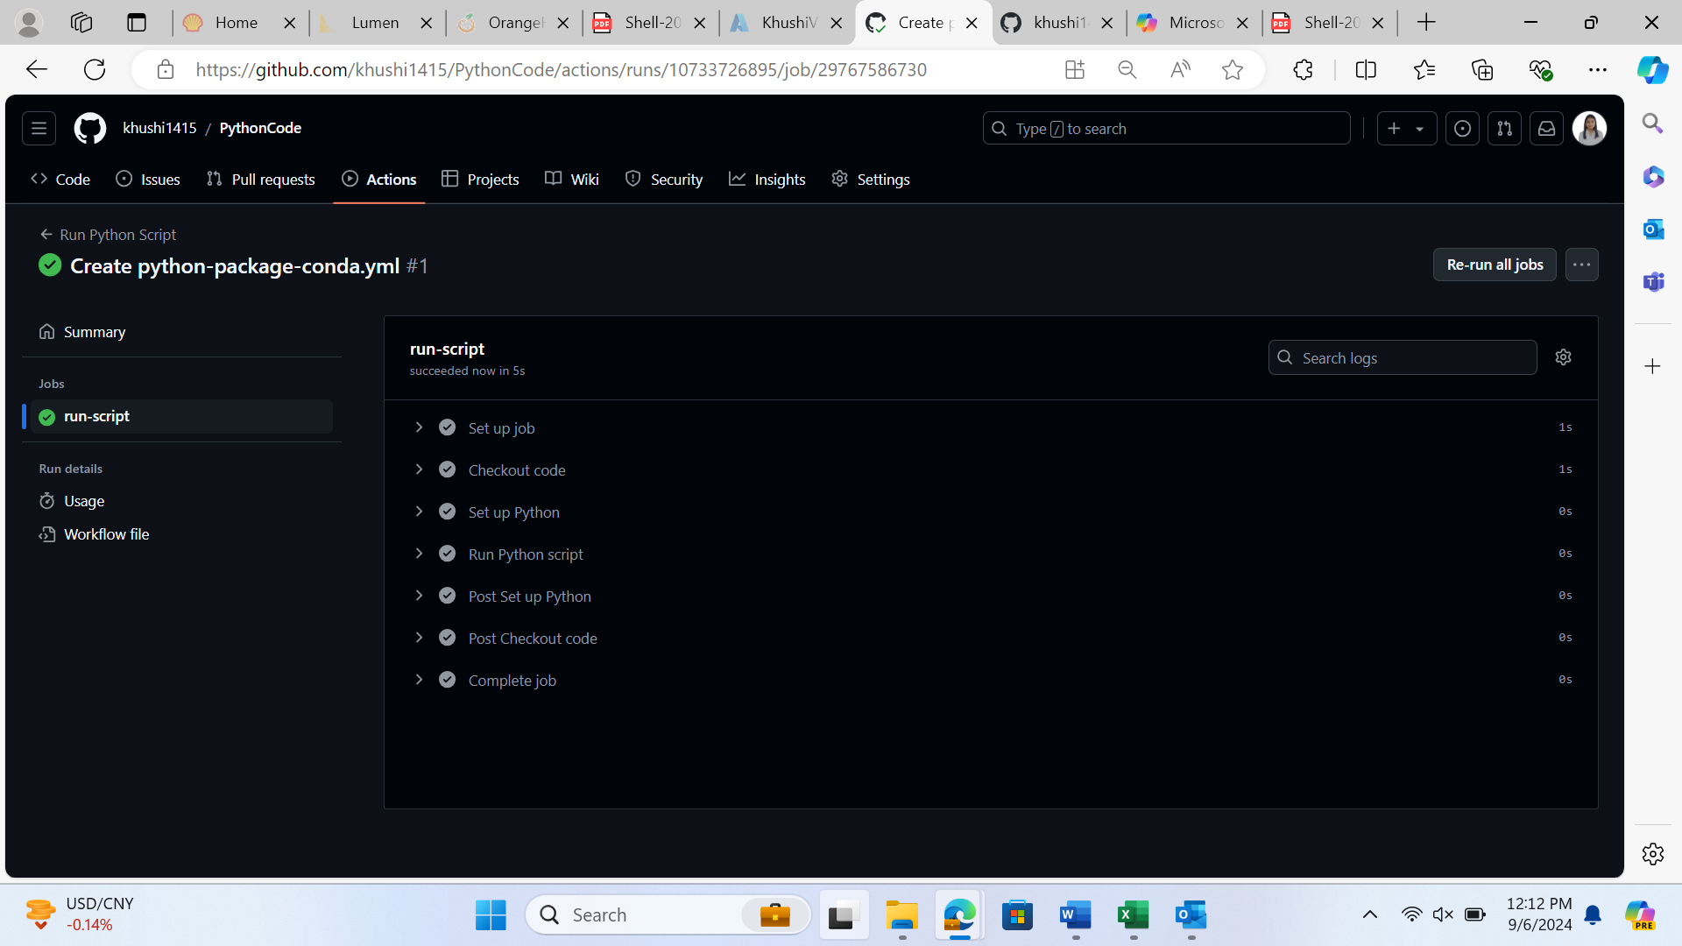

15. Modify the code in your repository to recheck the Workflow and the Build. For example, you could modify a Java class or update the pom.xml file.

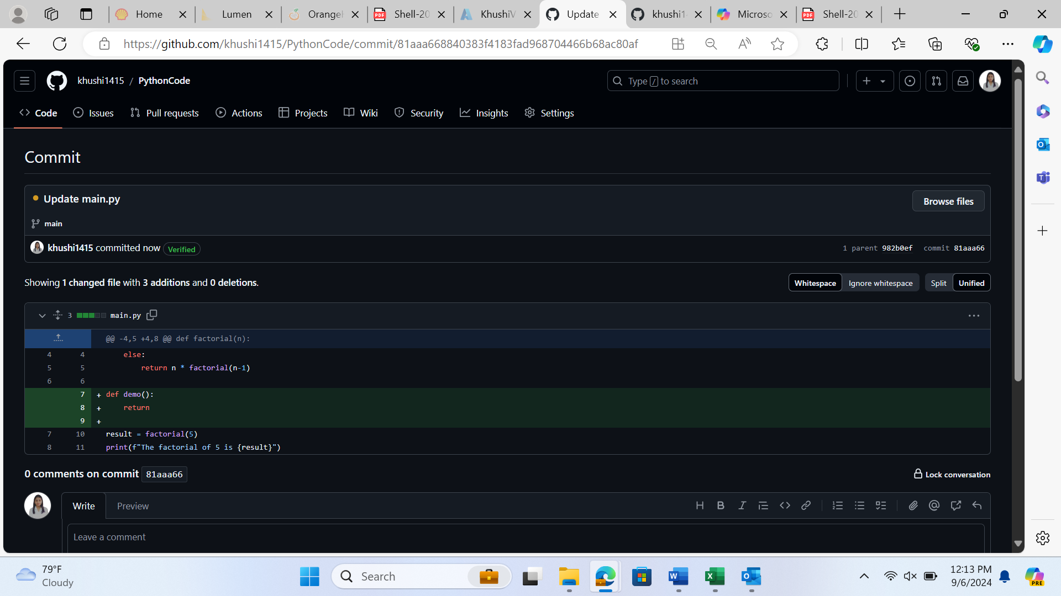

16. Commit it and monitor the build result

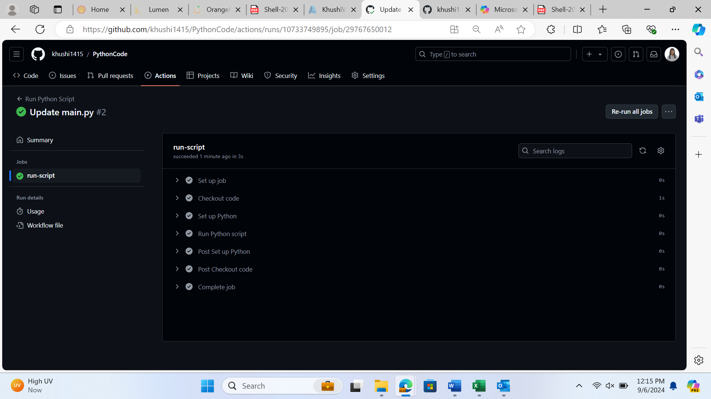

17. Update the screenshot of successful build and commit it in the repo.

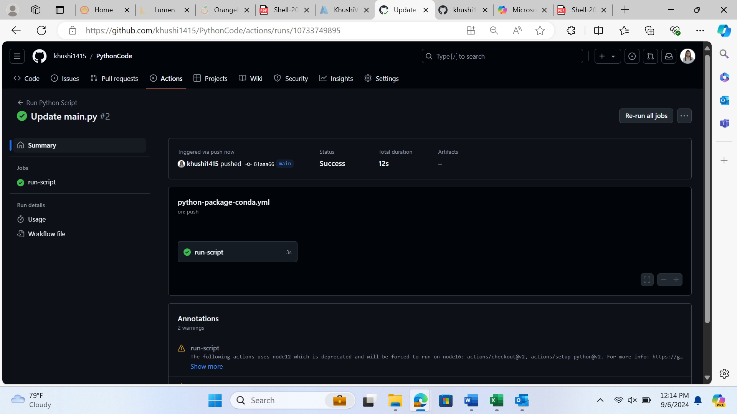

18. In your repository, add the created test cases report and defect report

